**Moderate to Severe Evaluation**

Sample_id : **7PDU7F**

**Link:**<https://app.animalbiome.com/pet/assessment/report/7b3f3854-592c-4c28-9e2b-f5c785fc25f0>

Cats and dogs:

Any two of the following:

(

High Red Flag Megamonas OR (failed)

High Red Flag Sutterella OR (failed)

High Red Flag Collinsella OR (failed)

Low Red Flag Bacteroides OR (failed)

Low Red Flag Blautia (failed)

);

OR

Dogs:

8 or more yellow flags;(failed) 1

OR 8 or more red flags;(failed) 0

High red megamonas,suttrella and collinsella failed.

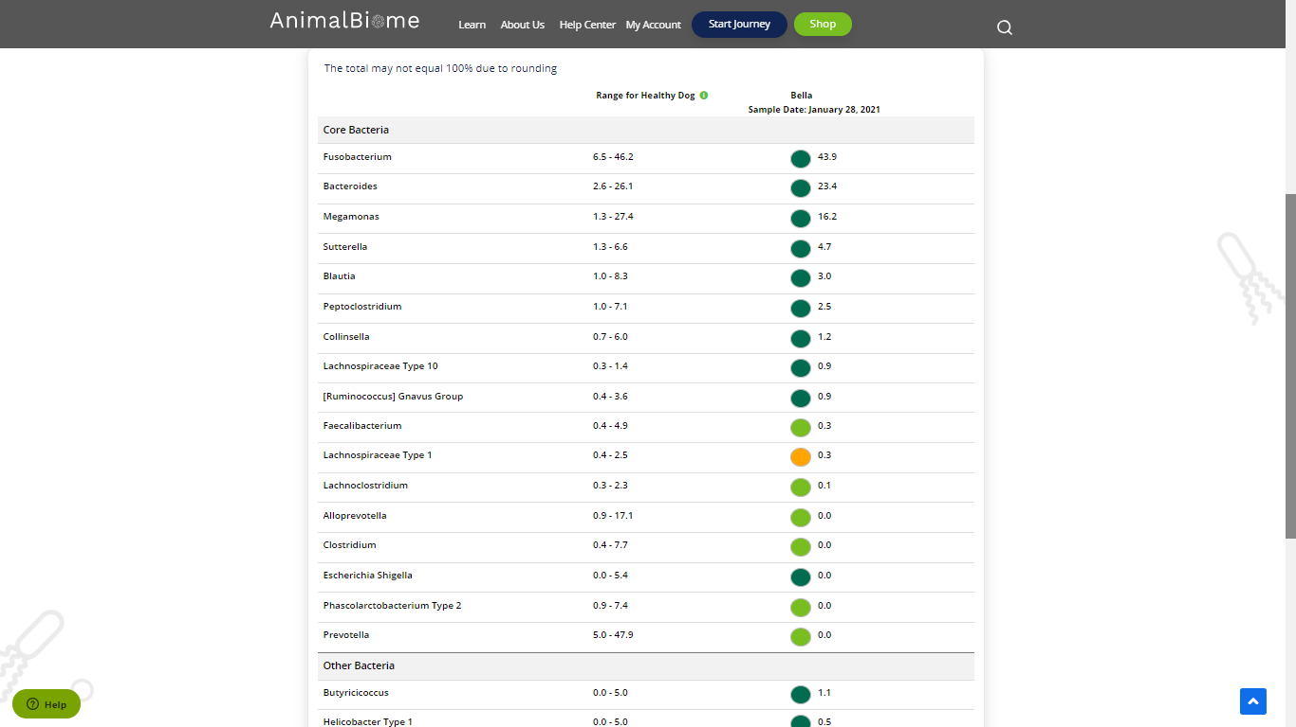

Low group evaluation:

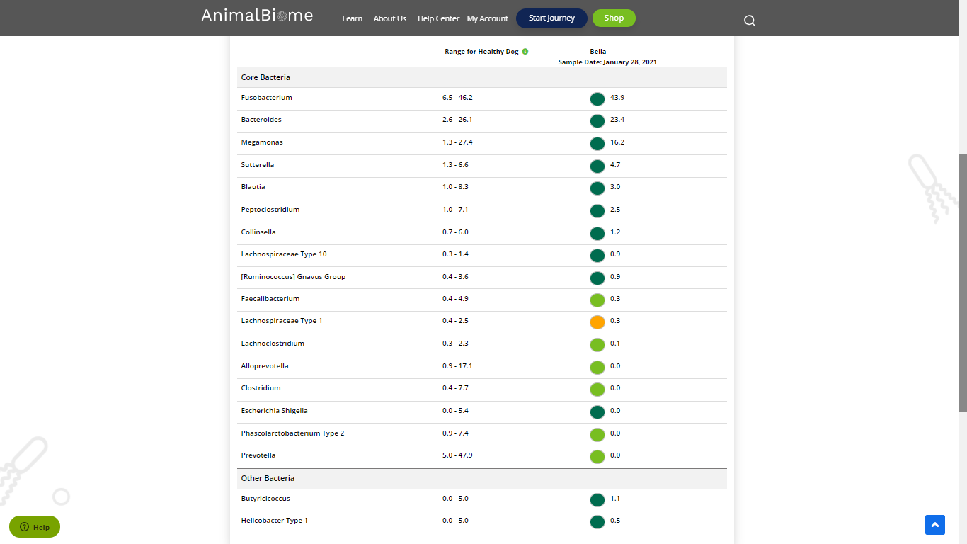

low red blautia : Failed.

Low red bacteroides : Failed (all conditions failed ) in the primary group.

Total yellow flags : 1

Red flags : 0

The result : False False False

Moderate to severe evaluation result : failed

**Mild to Moderate evaluation:**



**Mild to Moderate**

Cats and dogs:

Any Two

(High Yellow Flag Megamonas OR (failed)

High Yellow Flag Sutterella OR (failed)

High Yellow Flag Collinsella OR (failed)

Low Yellow Flag Bacteroides OR (failed)

Low Yellow Flag Blautia (failed)

)

OR

Dogs: 4-7 Yellow Flags (failed)

OR 5-7 Red Flags; (failed)

OR Cats and dogs: dietary recommendation of increase fiber or protein or decrease carbs(failed)

The result : False False False False

Mild to moderate evaluation results:Failed

Expected result : Balanced

Achieved result :Passed

